Nested loop system

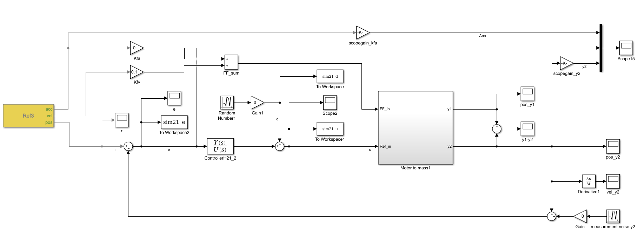

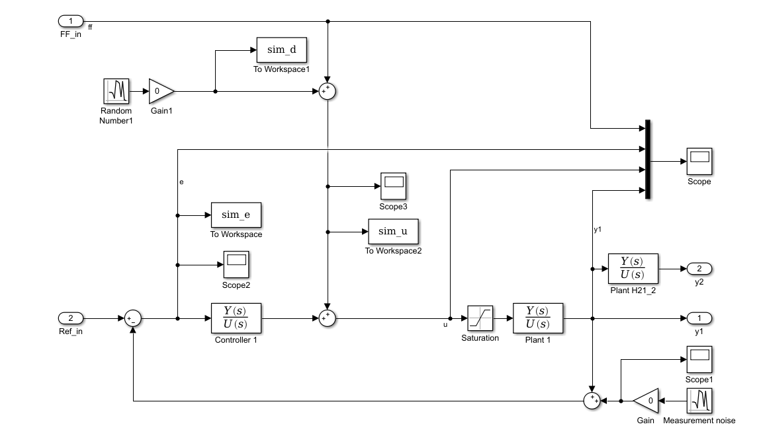

Controller from motor to mass 1 (inner loop)

H1_gain = 130; %130

Nf1 = 58.1; % Location of zeros [hz]

Nf2 = 41.1; % Location of poles [hz]

Nbeta1 = 0.02;

Nbeta2 = 0.013;

H1_notch = ((1/(2*pi*Nf1)^2)*s^2+(2*Nbeta1/(2*pi*Nf1))*s+1)/((1/(2*pi*Nf2)^2)*s^2+(2*Nbeta2/(2*pi*Nf2))*s+1);

P = 0.05;

D = 0.001;

H1_pd = P+D*s;

f_LP = 500;

H1_LP = 1/((1/(2*pi*f_LP))*s+1);

C1 = H1_gain*H1_notch*H1_pd*H1_LP;

C1_resp = squeeze(freqresp(C1,f*2*pi));

BW: 50 Hz

Gain margin -7,2 dB

Phase margin: 42 deg

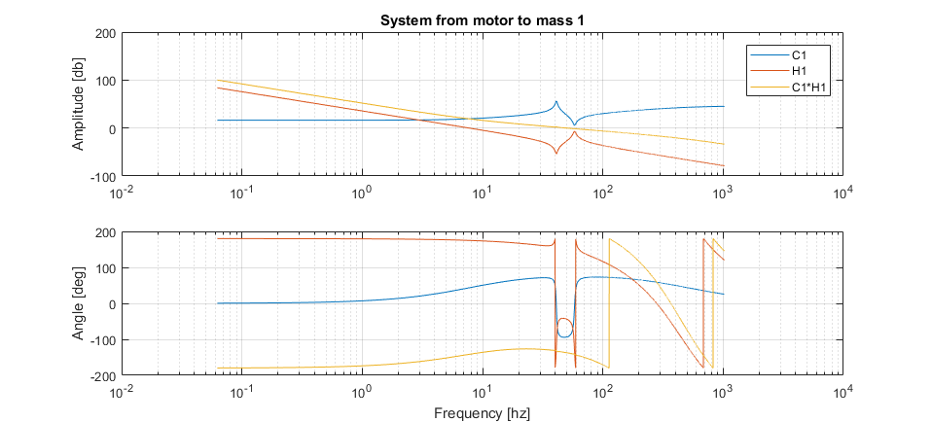

Controller for mass 1 to mass 2 (outer loop)

H21_gain = 15; %15

I_I = 1;

H21_I = (1+(I_I*2*pi/s));

Nf21 = 40.75; % Location of zeros [hz]

Nf22 = 150; % Location of poles [hz]

Nbeta21 = 0.01;

Nbeta22 = 0.1;

H21_notch = ((1/(2*pi*Nf21)^2)*s^2+(2*Nbeta21/(2*pi*Nf21))*s+1)/((1/(2*pi*Nf22)^2)*s^2+(2*Nbeta22/(2*pi*Nf22))*s+1);

f1_LP21 = 10;

H21_LP1 = 1/((1/(2*pi*f1_LP21))*s+1);

f2_LP21 = 0.5;

H21_LP2 = 1/((1/(2*pi*f2_LP21))*s+1);

C21 = H21_gain*H21_notch*H21_LP1*H21_LP2*H21_I;

C21_resp = squeeze(freqresp(C21,f*2*pi));

BW: 6.4 Hz

Gain margin -20.18 dB

Phase margin: 49 deg

